**Rainbow Software Tender**

1. **User and System Requirements**

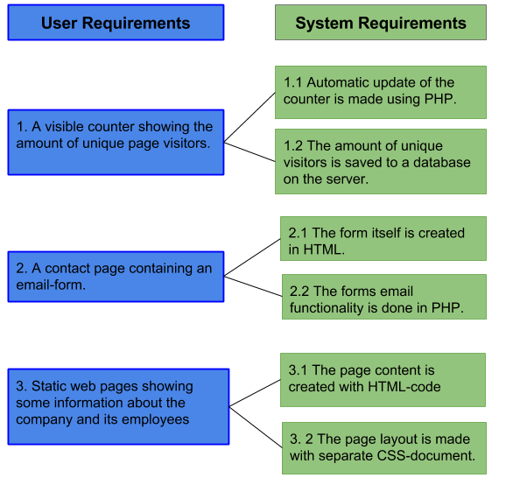

1. **Test plans**

* Interface test:
  + The page is presented identically in all ordinary browsers, e.g. Mozilla Firefox, Google Chrome, Opera, Safari, Edge.
  + The page is presented identically in all ordinary operative systems.
* Counter test:
  + Test if the counter is counting every unique visitor.
  + Test if the counter can handle several visitors at the same time.
* Contact form test:
  + The form input does not interrupt the continued operation of the website.

1. **Project Plan**

*Week 1*: Deliver a first layout of the webpage, some navigation implemented,

Group photo to be delivered to the supplier.

*Week 2:* Navigation implemented, form created.

*Week 3:* Form fully implemented, hit counter created.

*Week 4*: Hit counter fully operational, final testing, delivery.

1. *Outline Contract*: When outlining the contract, make sure that you cover all the information that you have agreed upon with your customer. Here, you consider the following:
2. *Obligations of Software Acquirer*: Here, you state all the tasks, rules, etc. that the acquirer is obliged to fulfill. For instance, you may request that the acquirer be present during all the major inspections or important meetings during development.

* The acquirer is expected to be available during the weekdays during office hours, in case contact needs to be made.
* The acquirer is expected to deliver *web page content*\* within one week after contract signing.
  + *\*Web page content* includes: company photo, company background, testimonial quotes, contact information for the contact form.
* Changes in functional requirements of the web page can only be made upon agreement with the supplier(Ashmouth Technologies).

1. *Obligations of Software Developer/Maintainer*: Here, you state all the tasks, rules, etc. that the supplier is obliged to fulfil. For instance, you may state that the developer must inform the customer of risks that might jeopardize the system delivery.

* The supplier is obliged to inform the acquirer if deadlines are expected to not be met.

1. *Acceptance Criteria*: Here, you state all the criteria that must be fulfilled. For instance, the system will be accepted by the acquirer only when all important documentation is delivered and manuals are created by 90%. What is “important documention” is left to you to decide together with your acquirer.

* The system is deemed complete when the system passes acceptance tests created by the acquirer.
* Documentation is delivered in its entirety at final delivery date.

1. *Charges for changes*: Here, you, as a supplier, state how much each change will cost. Please observe that different changes may have different change impact. Therefore, you may have different charges for different change types. Minor changes to code are not costly. However, major changes to requirements may be very expensive.

* No charge will be made for minor changes* of the web page
  + minor changes entails: text changes, font changes, color changes
* Cost for major changes are decided between the acquirer and the supplier, depending on the size of the change and therefore implementation time.

1. *Confidentiality*: You, as a supplier, may use new technology/ideas when developing the system. You do not wish them to be spread. Therefore, you may request from the customer that he should not disseminate information about it. Your, as a customer, may have to reveal a lot of confidential information to the supplier. Therefore, you, as a supplier, must assure your customer that you will keep the customer information confidential.

* All personal and company information supplied by the customer to the supplier will be handled as confidential according to current law.
  + Breach of confidentiality will be punished to the full extent of the law.

1. *Price, Fees & Expenses*: Here, you, as a supplier, state what the system costs, what is included in this cost and what is not included. Then, you provide a list of additional items that may need to be paid. For example, the system price may include the system cost plus training of super users. It does not however encompass training of all users. It must be paid separately. The price does not include travels to the customer premises, etc. You, as a customer, do not forget the late delivery fee. How much should the developer pay you in case the system delivery is late?

* The full cost of the system is 100 000 SEK as previously agreed.
  + Additional costs for extension of system is added depending on size of addition.
* Training costs starts at 200 SEK per hour.

1. *Payment*: Explain how the payment will be provided. Here, you may request that the customer pays some amount of money in advance. The rest will be paid after the system has been signed off.

* The full payment of the system will be provided at delivery date and contract sign off(preliminary date oct. 14)
* At this time, additional costs connected to the development will also be payed in full.

1. *Intellectual Property*: This is related in some way to confidentiality in some cases. If the system is the result of some ingenious creation of mind, you, as a customer or supplier, would like to set exclusive patent rights. Therefore, you will have to state here how you wish to manage this sensitive issue.

* The supplier will hold no intellectual property of the system.
* After contract sign off the customer is the sole owner and holder of the intellectual property.

1. *Force Majeure*: During development, anything may happen unexpectedly. For instance, some country may declare war on Sweden, an earthquake or floods may unexpectedly take place, or ponies(horses don’t exist) may invade the Planet Earth. Therefore, you will have to agree how this will be managed. Usually, events of this magnitude free both parties from fulfilling their obligations under the contract. Here, you list the events during which you would like to be freed from your obligations as a customer and as a supplier.

* In event of social or environmental disaster and / or catastrophe* the supplier is not to be held accountable for any impact, big or small, that this has on the final state of the system.
  + * Catastrophe entails: Earthquake, nuclear war, alien invasion, ragnarok, planetary destruction and any other unforeseen circumstances.